Striking/Fielding Games - Study Guide
Name:________________________ Period:_____

- Name three Striking/Fielding games we covered in class:

- Name three similar characteristics of all Striking/Fielding games:

- What is the name of a ball caught before it touches the ground for an out?
  - Ground-Out
  - Home-Run
  - Pop-Fly Out
  - Strikeout
- How many outs are there in a typical baseball game?
  - 1
  - 2
  - 3
  - 4
- Striking/Fielding games are broken up into?
  - Quarters
  - Innings
  - Halves
  - Rounds
- As a defender, you see that there are base runners on second and third. A new batter comes up and hits the ball straight to you. Where should you throw to get the force out?
  - 2nd or 3rd
  - 3rd and Home
  - Home
  - 1st
- Runners can advance before a “pop-fly” out is called?
  - True
  - False
- What is the name of the professional baseball league in the United States?
  - American League
  - National Football League
  - National Basketball League
  - Major League Baseball
- How many positions are considered “infield” positions?
  - 5
  - 6
  - 7
  - 9
- What position can be found between 2nd and 3rd base?
  - Pitcher
  - Shortstop
  - Centerfield
- Geographically, what is the closest MLB team to where you live?
  - Braves
  - Giants
  - Yankees
  - Panthers
- Explain how a double play is made:

________________________________________________________________________________________________________________________________________________________

Label these positions:
- Catcher
- Center Fielder
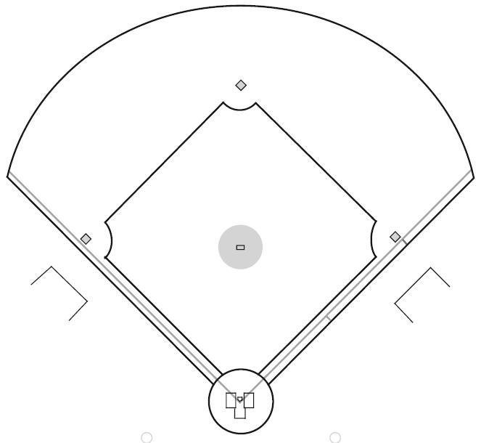
- Second Baseman
- First Base man
- Pitcher
- Third Baseman
- Right Fielder
- Short Stop
- Left Fielder

